

**Dealing with change:**

**Liquidity in evolving market structures**

Speech given by

Minouche Shafik, Deputy Governor, Markets & Banking

AQR Asset Management Institute, London Business School 27 October 2015

I would like to thank Grellan McGrath and Aakash Mankodi for their assistance in preparing these remarks. I would like to thank Niki Anderson, Alex Brazier, Paul Fisher, Jon Rand, Chris Salmon and Lewis Webber for substantive comments on earlier drafts. The views in this speech are my own, and not those of the Financial Policy Committee.

The global system is awash with liquidity. Central banks have increased their balance sheets to record levels by injecting vast amounts of liquid reserves into the system. The global issuance of debt has continued apace, most notably in emerging markets where the stock of non-financial corporate debt outstanding has more than quadrupled to $18trn since 2004.1 And in developed economies such as the UK, quantitative and qualitative measures of credit conditions are continuously improving.

Somewhat paradoxically, our inboxes are awash with circulars telling us that market liquidity is draining away. While it would be easy to dismiss these as doom mongering by those with a vested interest, in fact they have a point: there is evidence that financial markets have become more prone to bouts of volatility since the financial crisis (Chart 1), and that market liquidity – by which I mean the ability to trade in reasonable size without having a large impact on price – has become more fragile.

This matters. Financial markets should be a source of stability through the provision of funding for the real economy, the allocation of capital to where it is most needed, and the efficient transfer of risks. Prolonged periods of volatility and illiquidity discourage reliance upon markets to fund investment and trade, and incentivise businesses and households to self-insure rather than transfer risks to those who are better placed to manage them.

Thus far, the recent bouts of volatility we have witnessed have not jeopardised the continued growth of the real economy. Financial markets have recovered their poise reasonably quickly on each occasion, usually by the end of the day. After only short interruptions, governments, banks and businesses have regained access to markets and continued to raise the capital they need to continue to drive the recovery.

But the biggest tests may lie ahead. Over the coming years, three of the major factors that have dominated markets since the financial crisis seem set to change, and those tectonic shifts may pose a challenge for intermediation. In particular:

* Monetary policy normalisation: having reduced policy rates to record levels and used large scale asset purchases to push down on long term yields in response to the crisis, monetary policy makers in the US and UK will likely consider it appropriate to gradually tighten monetary policy should the recovery in their respective economies continue.
* Reversal of private capital flows away from emerging markets: Having provided around $6trn of investment in debt and equity over the past 15 years, private sector capital flows to emerging markets have begun to go into reverse amid concerns about the transition to slower potential output growth and the adjustment to lower commodity prices (Chart 2).

1 IMF (2015)

* Reversal of official flows back toward emerging markets: Having been a significant source of funds for business and governments in advanced economies as foreign exchange reserves were accumulated and commodity surpluses reinvested, official sector flows have begun moving in the opposite direction as emerging market governments seek to manage the depreciation of their currencies and use fiscal headroom (Chart 3).

These are not unreasonable actions for policymakers, private sector participants and the official sector to take. But what might be the consequences of these three tectonic shifts? There is a risk that if they trigger a broader “rush for the exit” in widely held positions, order-flow imbalances could preface a prolonged period of volatility, a severe reduction in market liquidity, and ultimately a loss of confidence in the ability of markets to contribute to sustainable growth. In short, there is a risk to financial stability.

To reassure ourselves that these flows can take place without the system being threatened, it is vital to ensure that we understand how the structure of markets has changed, what underlies those changes, and what they imply for market functioning. We must also consider how we (policymakers, infrastructure providers and market participants) should respond in order to minimise the risk of disorderly outcomes in the coming years. I will address these issues in the rest of this speech, drawing heavily on a paper that will be published by Bank staff later this week.2

## Changing market structure

Financial markets change. Over the 300 years from the beginning of the 18th century, the organised exchange of marketable securities evolved from gatherings in coffee houses3, through bowler-hat and umbrella clad days prior to the Big Bang, to the structure that existed immediately prior to the financial crisis. By that time, the trading of highly standardised securities such as shares of publicly listed companies and commodity futures was largely on exchange, while the trading of fixed income and currencies was mostly done Over The Counter (OTC) with market makers who bought and sold securities using their own balance sheets.

Change has continued over the period since the financial crisis – including in the how, who, where and why of trading. Most visible has been changes in *how* transactions are agreed and executed – with electronic trading taking over from voice trading in many markets. For example more than half of all

dealer-client gilt trades are now executed electronically4. In turn, the availability of visible and reliable up to date electronic prices has facilitated an increase in automated quoting and trading based on pre-defined algorithms.

2 Anderson et al (2015)

3 What was to become the London Stock Exchange first met at Jonathan’s Coffee House, located – fittingly – in Change Alley.

4 50-70% by value of trades between dealers and clients in the gilt market are undertaken via electronic platforms.

*Who* is on the end of these trades has also changed. Although the fund management industry has grown considerably since the financial crisis, market making-banks actually tend to carry less inventory (Chart 4). They have also lost market share to new kinds of market makers – for example Principal Trading Firms (PTFs) who specialise in high frequency trading and hold positions for only very short periods of time. By way of example around half of trading in on-the-run US Treasuries in the interdealer market is now done by PTFs.5

Participants also have much more choice about *where* to transact, ranging from single-dealer to all-to-all platforms. Many of the markets that were steadfastly over-the-counter have begun to move toward more transparent centralised exchange-like trading, with on-the-run government bonds and vanilla interest rate swaps being the most notable. By contrast some of the markets previously held up as beacons of

on-exchange trading, such as the equity market, have begun to move toward less well lit venues, partly motivated by the desire to conduct large trades discretely.

Finally, there has been a subtle change in *why* transactions are undertaken. Pro-cyclical trading strategies have become increasingly popular. For example, Commodity Trading Advisors (CTAs) tend to use quantitative trend-following strategies largely executed in futures markets; and funds that target a specified level of risk tend to enter an asset class when volatility decreases over time and exit when volatility increases. Of course different trading strategies will always come and go, but what’s notable about those currently enjoying popularity is their potential to amplify market moves.

The result of all of these changes is that the macrostructure (that which is visible to the naked eye) and microstructure (that which is only visible under a degree of magnification) of financial markets have been transformed, presenting ongoing challenges and opportunities.

## Changing market function

It will be important to understand the implications of these changes for market function. Bid offer spreads in many markets have reduced since the financial crisis (Charts 5 & 6). And over the past 3 years implied volatility has averaged at levels similar to the 2004-2007 period (Charts 7 and 8). So on a good day, for some markets at least, the reduction in liquidity offered by market-making banks appears to have been more than offset by the increase in liquidity provided by other participants and venues.

5 US Department of the Treasury, Board of Governors of the Federal Reserve System, Federal Reserve Bank of New York, US Securities and Exchange Commission and US Commodity Futures Trading Commission (2015)

But financial markets also seem to be more prone to bouts of volatility now than they were prior to the

crisis – the frequency of spikes in implied volatility is more like the period 2000-2003 than 2004-2007. From a financial stability point of view, how markets function on these “bad days” is of greater interest, and four episodes over the past year or so offer us a rich seam of information:

* In an episode now known as the “flash rally”6, 10 year US Treasury yields fell by 29bps in just over an hour on October 15th 2014 – a move equivalent to almost seven standard deviations of historical daily changes. During the moves market makers widened bid-offer spreads or reduced order sizes, but volumes traded actually increased – in particular driven by PTFs employing high frequency trading strategies. The move went into reverse once prices had risen sufficiently that large resting sell orders away from mid-market prices came into view on screens.
* In January of this year, the Swiss franc appreciated by 28% against the euro over a period of 20 minutes following the removal of the peg to the euro by the Swiss National Bank. During the episode, many major automated trading systems ceased to provide live pricing as they were switched off or overridden; and the market for Swiss francs was characterised by wide bid-offer spreads, unreliable prices and a lack of liquidity.
* During the “Bund tantrum” of last spring, yields on 30 year German debt rose by 1.1pp over just 50 days in response to little data of note. The move is thought to have reflected the unwinding of crowded trades that had built up in anticipation of asset purchases by the ECB. The futures market – in which trend following CTAs are particularly active – led much of the move.
* In August, sharp falls in Chinese equity markets were the backdrop for a wave of risk reduction across a range of developed markets. There were sharp and abrupt price moves in usually liquid foreign exchange pairs – such as dollar-yen – and dislocations emerged in the pricing of exchange traded funds in the US.

Two things are striking about these episodes. The first is their heterogeneity: for some there was an obvious proximate trigger, for others not. Some involved a reduction in automated trading, others an increase. Some originated in derivative markets, others in cash markets. And some involved notable market dysfunction, while in others pricing was continuous and volumes traded actually rose.

The second is that although they have all involved periods of volatility, none has so far jeopardised systemic stability. Nor have they so far had an enduring effect on household, corporate and government’s ability to finance the recovery since any disruption to primary issuance has proved short-lived.

6 Dudley (2015)

It might be tempting, therefore, to conclude that there is nothing that we could or should learn from these episodes. But – as you can probably guess – I think that would be overly sanguine. While the evolving market structure has resulted in reduced bid offer spreads and quicker execution in many markets in times of low volatility, these episodes show us that banks and non-banks’ ability and willingness to put capital at risk in the face of large scale order flow imbalances has changed. Put another way, although liquidity may on average be higher, the risk that liquidity may not be available when it is needed most has also risen.

## What underlies these changes?

Many of the circulars we receive point to *regulation* as the key driver behind these changes. It is undeniable that there is more regulation now than prior to the financial crisis, and that some of this has played a role in changing the incentives for banks to increase their balance sheets. That was indeed part of the objective of regulation: prior to the crisis the system was undercapitalised and liquidity mismatches were too great.

But given the heterogeneous characteristics of the liquidity episodes we have witnessed over the past year, it’s unlikely that one development can explain all of the changes in market liquidity. Regulation is only part of the story. It seems to me that three other explanations – risk awareness, evolution and innovation – have played just as important a role.

The experience of the financial crisis gave banks greater ex-post *awareness of the risks* that were implicitly (and in some cases unwittingly) being run in years gone by. The larger a business is the greater market, liquidity and conduct risk it runs. As a result of (re-)learning this, banks have become more wary of extending their balance sheets, and some now tell us that their internal risk limits are more of a binding constraint than regulation – consistent with the fact that their inventory levels declined before most of the post-crisis regulatory framework had been put in place. As importantly, individual traders are less willing to take on large positions because the experience of the crisis still bears upon their mind-sets and upon their reward structure.

Taken collectively, the response of regulators, banks and individuals to the financial crisis is recognition of the fact that – with the benefit of hindsight - the over-extension of banks’ balance sheets in the provision of liquidity before the crisis was ultimately unsustainable.

The reduction in the relative size of dealer balance sheets may also be a natural process of *evolution* as the market-making industry matures and emphasis is placed on using its warehousing capacity efficiently rather holding lots of inventory. Market making wouldn’t be the first industry to go through such a change: Just In Time management swept through manufacturing in the 70s and 80s with its focus on minimising waste, eliminating inventories, and quickly responding to changing market demand. More recently, supermarkets have reversed their once relentless expansion of retail space, and started moving away from

inventory-intensive hypermarkets toward smaller retail units.

Indeed, moving toward smaller in-store inventories is not the only parallel between retailing and market making: both have also been dramatically changed by *innovation*. Just as the rise of internet shopping has given consumers access to a broader choice of shops and much easier means of price comparison, so has electronic trading facilitated new ways of matching buyers and sellers in financial markets, and added to the data generally available for price discovery.

Although it is impossible to separate or quantify the effect of each of the influences on market structure over the years since the crisis, it is difficult to argue that increased risk awareness, evolution and innovation would not have existed without regulation. It is therefore difficult to argue that were it not for regulation, many of the changes we have seen in market structure would not have taken place.

## Dealing with change

Change is ongoing – indeed one would expect well-functioning financial markets to change continuously. But we are in a position now to ask how we should adapt to ensure that the resilience and effectiveness of financial markets is maximised. I say “we” because the response will likely fall jointly to policymakers, infrastructure providers, and market participants.

Because we are at an important juncture, it is vital that those affected discuss ways to maximise the benefits of evolving market structures, while minimising the risks. It is with this in mind that the Bank of England is hosting an Open Forum in November, which will tackle issues such as the impact of regulation; how financial innovation can support the economy; and the role of liquidity in the broader economy7. We hope that the Forum will be an important step towards helping financial markets, regulators and the public to constructively deal with change in a way that serves the common good.

Let me start with some thoughts on what policymakers can do. First, given the breadth of changes made to the regulatory framework we do have a responsibility to assess the cumulative impact of various reforms and how they interact. As Jon Cunliffe said last week, it would be surprising if we didn’t find areas where the reforms do not work as intended, and there will be elements that need to be adjusted. 8 However, you should not expect the underlying tolerance of micro and macro prudential regulators to risk will be changed. The cost of financial crisis has proven to be very large – the level of output in the UK is around 15% below a continuation of its pre-crisis trend. More to the point, liquidity provision under the previous structure was ultimately proven unreliable when it was needed most, and a having a better capitalised, more resilient core of the financial system will improve the resilience of liquidity over the long run.

7 The debate is already underway on social media (#BoEOpenForum). More details available at [http://www.bankofengland.co.uk/markets/Pages/openforum.aspx.](http://www.bankofengland.co.uk/markets/Pages/openforum.aspx)

8 Cunliffe (2015)

Second, reflecting the fact that markets have become more responsive to news, we monetary policymakers can ensure that we provide clarity around our reaction function when the time comes to exit from very accommodative monetary policy. The Monetary Policy Committee has continued to increase transparency around its decision making process in recent years by providing greater access to forecasts, publishing minutes of meetings alongside the decision itself, and providing various forms of forward guidance - including that when increases in Bank Rate do come, the existence of persistent headwinds means we expect the pace of tightening to be gradual and limited compared to previous cycles. These don’t commit us to any particular path for policy – to do so would imply more certainty than we actually have about what the future holds – but they do reduce the scope for an overreaction in financial markets as the data evolves.

Third, given the changing nature of the financial system, we also have a duty to ensure our provision of liquidity insurance remains fit for purpose. The Bank of England has already taken significant steps in the right direction, by adding several tools that should prove useful in the event of a sustained liquidity shock:

* The Bank’s published framework for providing liquidity insurance to the banking system has been overhauled. The range of counterparties to whom we will provide liquidity has expanded – including to broker-dealers – and the collateral we will accept is much broader. And our regular operations have built in counter-cyclicality by which the quantity of funds we will lend increases when the pattern of bids suggests it is necessary. The result is that market-making banks can be confident of their ability to fund a wide range of assets for terms of 6 months or longer, even in times of general stress.
* At the height of the financial crisis, the Bank took the step of acting as a Market Maker of Last Resort (MMLR) in certain funding markets whose illiquidity posed a threat to financial stability – including sterling commercial paper and corporate bond markets. Were liquidity to deteriorate again to such an extent that it was judged to pose a systemic threat to financial stability or the transmission of monetary policy, the Bank would stand ready to act as a market maker of last resort again.9

But these are not a panacea. Although widening the breadth of our facilities would increase the ability of market-making banks to provide liquidity in times of stress, it may not increase their willingness to do

so – that would be a function of their risk appetite at the time. And although Market Maker of Last Resort had some success in the financial crisis, it has natural limitations. It would be difficult, for example, for the Bank to act as a market maker of last resort in assets denominated in currencies other than sterling.

Some of the responsibility for responding to changes in market structure will fall to infrastructure providers. Just as the success of the movement to Just In Time supply chain management was facilitated by

9 More details on the Bank’s operations can be found in the Sterling Monetary Framework Red Book: <http://www.bankofengland.co.uk/markets/Pages/sterlingoperations/redbook.aspx>

improvements in communication and transport links, the success of changes in financial markets will be dependent upon the existence of robust infrastructure that acts as a stabilising force. The introduction of MiFID II will do much to enhance the stability of markets as more trading moves onto centralised venues. It will require such venues to have stabilising mechanisms – such as circuit breakers - in place, and will extend pre- and post-trade transparency. As the structure of financial markets continues to evolve in future, it will be important to ensure that the use of stabilising mechanisms and calibration of transparency are regularly reviewed.

Ultimately, however, much of the responsibility for adapting to changes in market structure lies with those who determine prices – i.e. market participants. Issuers should consider whether changing market structures warrant a re-examination of the merits of standardisation in order to promote secondary market liquidity.

Investors must price liquidity appropriately, and manage it prudently, as the Financial Policy Committee urged in its most recent statement. When making the decision to purchase an asset they should ensure that their investment horizon is aligned with the inherent liquidity of that asset. And they also need to understand that abundant market liquidity in normal times may not be indicative of the ease with which they can exit a position or effectively hedge it in times of stress. When it comes to matters of market liquidity, the old adage “caveat emptor” or “let the buyer beware” still applies.

# C:\Users\324202\AppData\Local\Microsoft\Windows\Temporary Internet Files\Content.Outlook\QQ8SJY8B\aakash chart (5).pngCharts

|  |  |
| --- | --- |
| **Chart 1:** Impact of asset price news on volatility in UK equity and credit markets(a)(b) | **Chart 2:** Net private capital flows to EMEs**(a)(b)(c)** |
| Sources: BofA Merrill Lynch Global Research, Thomson Reuters Datastream, IMF GFSR October 2014 and Bank calculations.   1. Based on exponential GARCH (EGARCH) model, which allows for conditional volatility to react differently to negative and positive shocks to returns. UK equity refers to FTSE All-Share, UK credit to sterling investment-grade corporate bonds 2. Pre-crisis: Jan. 2001-June 2007. Post-crisis: April 2009-Jan. 2015 | a) Net private capital flows is the financial account net of offficial reserves accumulation. (b) Emerging Asia excluding China comprises India, Indonesia, Malaysia, the Philippines and Thailand; emerging Europe comprises Poland, Romania, Russia and Turkey; Latin America comprises Brazil, Chile, Colombia, Mexico and Peru. (c) 2015 data are linear extrapolations of H1 2015 data.  *Source: IMF and Bank calculations.* |
| **Chart 3:** EME reserves accumulation(a)(b)(c) | **Chart 4:** US Primary Dealers’ inventory in corporate fixed income securities relative to market size(b)(c) |
| (b) Emerging Asia excluding China comprises India, Indonesia, Malaysia, the Philippines and Thailand; emerging Europe comprises Poland, Romania, Russia and Turkey; Latin America comprises Brazil, Chile, Colombia, Mexico and Peru. (c) 2015 data are linear extrapolations of H1 2015 data.  *Source: IMF and Bank calculations.* | Sources: Federal Reserve Bank of New York, SIFMA and Bank calculations.   1. US primary dealer net positions in US corporate securities, which include corporate bonds and non-Agency RMBS and CMBS, with a remaining maturity of at least 12 months. 2. Outstanding US corporate securities, which include corporate bonds and non-Agency RMBS and CMBS, globally in all currencies. |

|  |  |
| --- | --- |
| **Chart 5:** Corporate bond bid-offer spreads(a) | **Chart 6:** Equity market bid offer spreads**(a)(b)(c)** |
| (a) TRAX bid-ask spread index (BASI) for US, and UK corporate bonds. For UK index, bid ask spreads are as a percent of price, for the US index they are absolute differences in yields. Source: MarketAxess. | Sources: Bloomberg and Bank calculations.   1. Bid ask spread calculated as proportion of mid price. 2. Using constituents of the FTSE 100 and NASDAQ 100 indices as at 03/08/2015. 3. Series shows aggregate of constituent bid ask spreads, weighted by daily trading volume. |
| **Chart 7:** Equity Implied volatility (VIX)(a) | **Chart 8:** Interest rate implied volatility **(**MOVE) (a) |
| Source: Bloomberg and Bank calculations  (a) VIX index is a measure of market expectations of 30-day volatility as inferred from S&P500 stock index options. | Source: Bloomberg and Bank calculations  (a) MOVE index is a yield curve weighted index of the normalised implied volatility on one-month Treasury options |

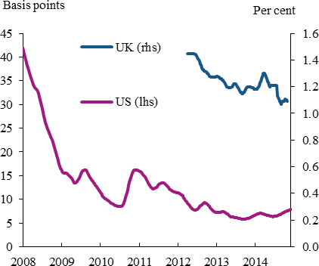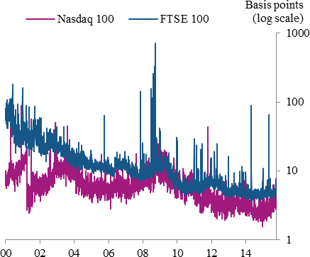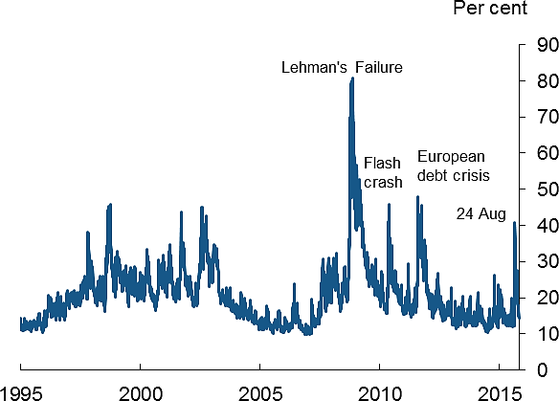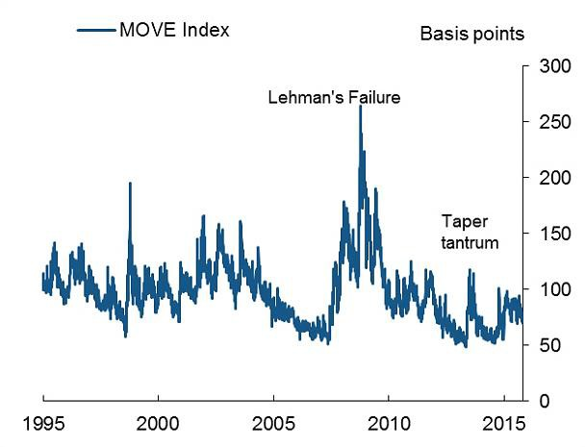

**References**

Anderson, N, Webber, L, Noss, J, Beale, D and Crowley-Reidy, L (2015), The resilience of financial market liquidity, *Bank of England Financial Stability Paper*, forthcoming 30 October.

Cunliffe, J (2015) Market Liquidity and Market-Based Financing, *Speech to the British Bankers Association International Banking Conference.*

Dudley, W (2015) Regulation and Liquidity Provision, *Remarks at the SIFMA Liquidity Forum*, New York City.

IMF (2015) Global Financial Stability Report: Vulnerabilities, Legacies and Policy Challenges, October 2015.

US Department of the Treasury, Board of Governors of the Federal Reserve System, Federal Reserve Bank of New York, US Securities and Exchange Commission and US Commodity Futures Trading Commission (2015), ‘Joint Staff Report: The US Treasury Market on October 15, 2014.’